Cause and Effect Chart
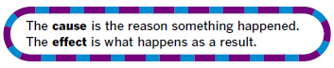
Identify an event or an issue. Find the cause of event or issue by asking, “Why did this happen?”
Find the effect or effects by asking, “What happened as a result?”
